Computer Language Flat & Structured Interchange

Commands & Classes Loosely Coupled

I am working out the idea here as I go along. The explanations may need to be redone in the future.
In the programming language C++ a command of a class is automatically also a global command. The first parameter of the global command, is the object the command is called upon. This is called the this-argument. If the global command has more parameters, that are objects, those objects’ public members are accessible from within the command. Only for the this-argument, it counts, that the command has access to private members of the argument.

Command not part of class definition
A bold statement, that emphasizes total interchangability of global commands and class commands:

Any command, that takes an object as an argument, becomes a command of this object’s class.

A parameter adds the command to the class of the parameter.

The principle commands & classes loosely coupled could also be called: procedural and object oriented interchange, because instead of viewing commands as part of classes, you can also view them as a flat list of global commands.

You shouldn't see the command as being directly part of a class. A command just seems to be part of a class. In object oriented programming, a command also just seems to be part of an object, while it is really only defined inside the class. In Computer Language commands are not even part of a class anymore. They just seem to be part of a class, while they are really independent entities.

When you program a command, that does something, the action is immediately available in the context of any type of object, that has anything to do with that command.

This makes it so that the very same command can be part of several classes. This makes commands independent entities, that are not tied to a class.

The software development community has put up a fight to make commands part of a class, instead of having a flat list of global commands. And here I claim the opposite. Like it is a step back in the development of computer programming. But this system doesn’t pick either side. Commands are both independent entities as well as part of a class. This system makes flat and structured completely interchangable.

It is actually the flat part that is physically stored. The structured part is simply derived from it. The structured part is imaginary and volatile. The flat part is fixed and real.

Calling a command on an object
A command can be called on each object, whose class is a parameter of the command.

When you call a command on an object, the call points to the command of an object, but the object is also visible as a parameter of the call.

Command’s access to private contents of classes
The this-argument in C++ was special: a command has access to the private contents of the this-argument.

The fact, that a command can access the private contents of a class is a special option. Commands do not decide on their own whether they have access to a class’s private contents. A class grants a command access to its private contents.

This makes the command more part of the class, but a command is still a separate entity, that can apply to multiple classes.

Private members of a class are useless, unless there are commands that use these private contents. So the informal connection between classes and the commands, that is established by the class’s granting the command access to its private contents, is very tight, and those commands are actually the protectors of that class’s private contents.

Classes giving commands access to their private contents formally is a form of access control. But informally the commands, that have access to the private contents of a class, are the protectors of that class. The class appoints these protectors. Commands do not decide on their own to become such protectors.

Commands with fixed logical residence
A class granting a command access to its private contents, creates a tight informal bond between the class and the command. The command becomes part of the class in a way, even though a command still is a separate entity. Another way to make a command part of a bigger whole, is to give a command a fixed logical residence. A command already has a fixed physical residence, being the place where the command is stored on disk permanently. A command is stored somewhere, just like an object. But a command can also be given a fixed logical residence. This fixed logical residence shadows the fixed physical residence and gives a command a fixed logical position. The logical residence is the target of all references to the command. Only the fixed logical residence has access to the physical residence of the command.

It is actually advised to give a command a fixed logical residence. Preferrably, you make the command logically part of a module, because modules will bundle together classes and commands to a single logical unit of functionality. Don’t make the command part of a class. This binds a command too much to a class. Give a command the freedom to become part of multiple classes, rather than tying it up to a single class. A class’s granting a command access to its private contents already establishes a tighter bond, and the command will be visible as part of the class anyway, even when the class is not the fixed logical residence of the command. And even when you do give the command a fixed logical residence inside a class, the whole rest of the system is going to ignore that: a command call will still be a call upon multiple objects. Only the definition of the command would then be bound to the class.

A globality can get overloaded command names, when all commands are logically tied to a module, but this was already the case in languages such as C++. In C++ all the commands of all classes were already reachable globally. In Computer Language, commands can even be overloaded having the same signatures, because in the diagram they are different symbols, and can be reached separately regardless of their name or signature.

Automatic containment of independent commands
commands can be called in arbitrary places, just like objects can be referenced in arbitrary places. In the article about automatic containment, for objects it is extensively discussed, how that makes objects logically part of multiple wholes. However, a single logical residence of the object was appointed, that is the real residence of the object itself, while all the other locations, were mere references to the object. Also: from the perspective from which you looked at the object structure, a single logical location within view was appointed to represent the object itself, even though the real location of the object was out of sight.

It works the same for commands. A command has a fixed physical location, where the command is physically stored on disk. This physical location is usually shadowed by a fixed logical location, which is the logical target residence of the command. The fixed logical location usually resides directly inside a module. Any pointer to the command directly or indirectly points to the logical target location of the command. However, when the target location of a command is out of sight, a single location is appointed to be the intermediate, imaginary target of the command references.

A reference to a command is either a command invokation, or an inactive pointer to the command. For now only command invokations are considered, also called command calls.

In this section, about automatic containment of commands, I will first look at commands as totally independent entities, not tied to a class at all. I will actually explain here how a more structured view on a command call is translated to a flat view on it, because the flat view is how things will be physically stored. In later sections, I will show, how a flat view will translate to a structured view, and explain how a call upon a global command turns into a call upon multiple objects.

A call to a command contains parameters, to which objects need to be assigned. When an object is assigned to a parameter, the parameter is tied to the closest imaginary reference to the object. The command call will simply contain object references pointing outward to imaginary object references.

The command call symbol itself, so not the command parameters, but the command call itself, will point to the closest imaginary reference to the command definition. The command call symbol will be connected to the closest imaginary reference with a class line (a dashed line), because the command symbols will represent the same class of command, not the same instance of the command (a call itself is an instance of a command, but the commands tied together represent the same definition, not the same call).

The automatic containment of commands has one particular difference with automatic containment of objects. Imaginary references to objects are not show in the diagram, unless the object is actually used in that part of the diagram. commands are shown in the diagram, even if they are not used in that part of the diagram. Imaginary references to commands are shown inside each object that has a class, that the command uses as one of its parameters. The imaginary references to commands, that are put inside objects, are there, even when they are not used in that part of the diagram. That makes the command available from any object, that could be used by the command. That is a good thing. All commands, that operate on the object are directly available from that object.

Now I will explain, how you create a command call in the programming environment. A command call is created inside another command. First you create a command call, with no particular command assigned to it yet.
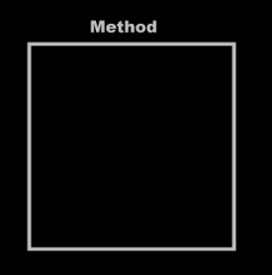 | → | 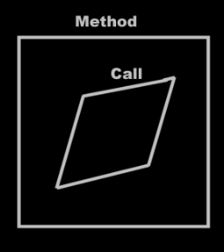
Next you tie the command call to a particular command. This command resides usually inside an object. You tie the call to the command inside an object.

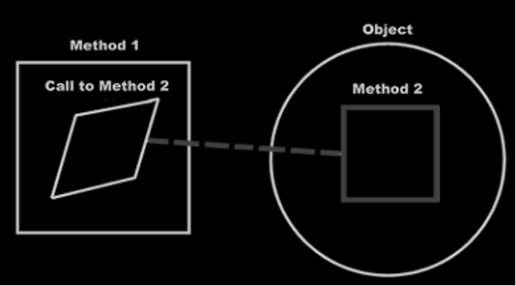

Command 1 now calls command 2 of the object in the diagram. After you’ve done this, the diagram transforms. You, the programmer, tied the call to a command inside an object. The system under the surface ties the command call to the actual command definition, which could be far out of sight.

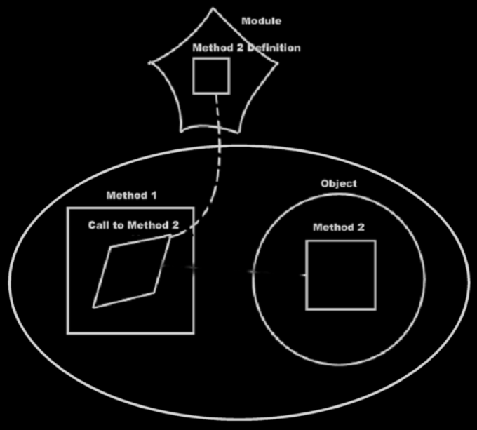

After that, the command call is imaginarily tied to the command definition through imaginary references, that eventually lead to the command definition.

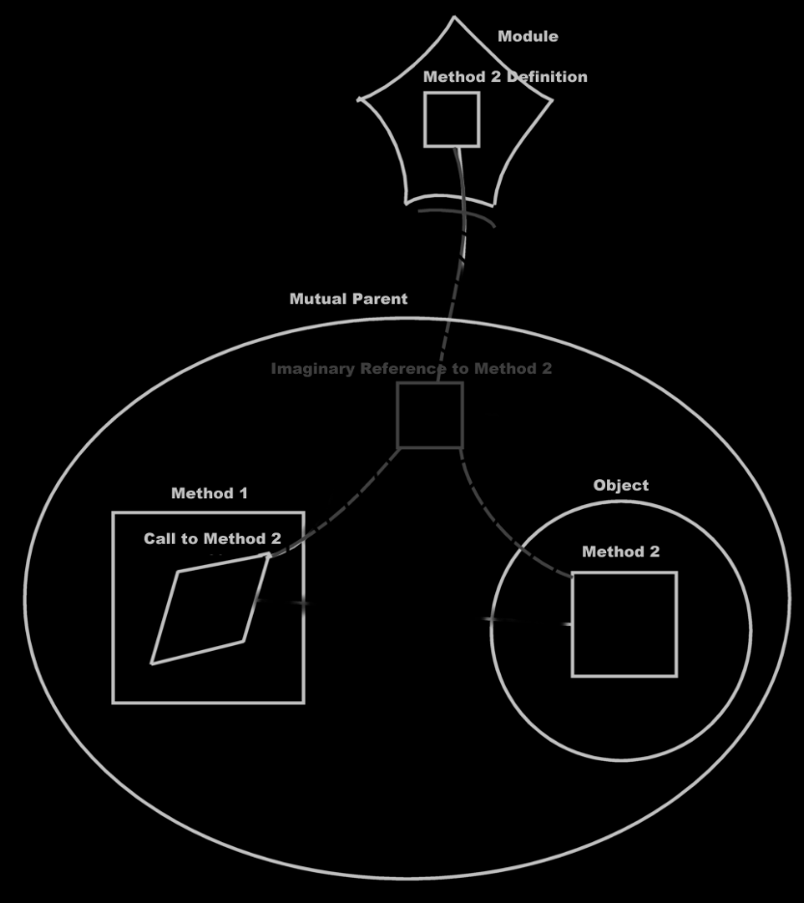

The command call is tied to the imaginary reference to the command, but the imaginary command definition inside the object is also tied to the imaginary reference to the command.

The command call contains pointers to the arguments, which means, that the line, tying the call to a command inside an object:

is now replaced by an object reference inside the call that points to the object.

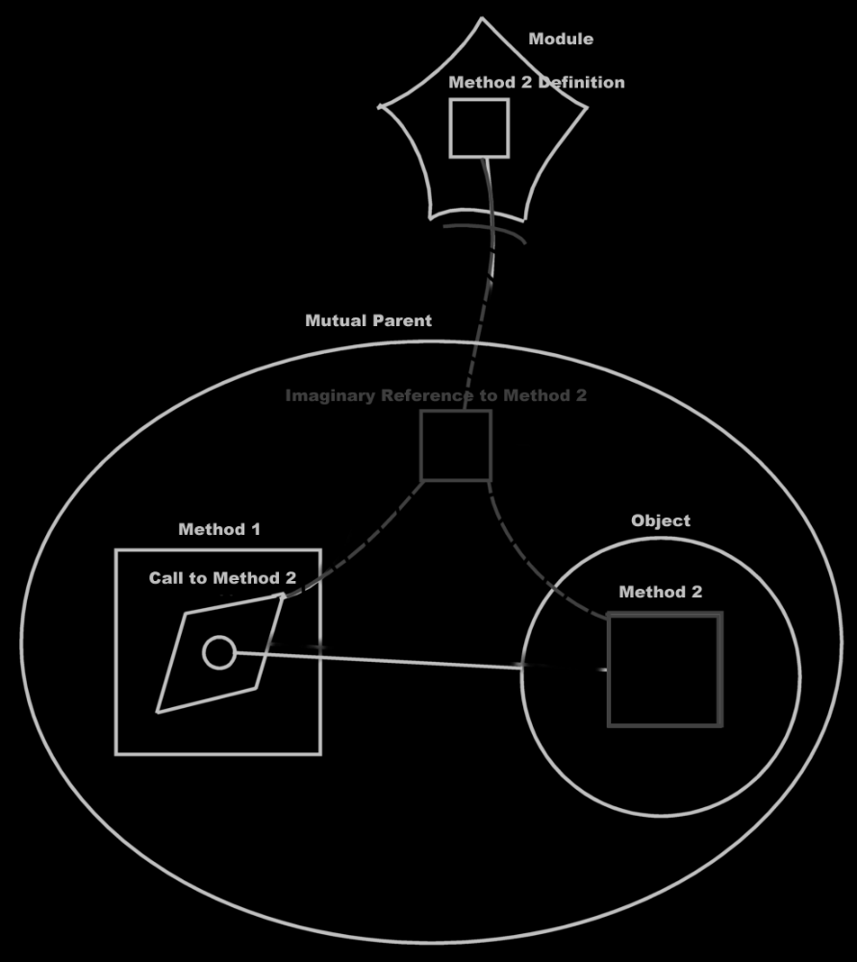

The imaginary command reference inside the object isn’t even pointed to anymore. It just sits there, just as an imaginary reference, that nothing is tied to, just to see what actions you can perform on the object and what you can make the object do. The object simply says: “Hello, this is what you can do to me.” The object commands do point to the command definition through imaginary references, but nothing is pointed to it anymore. After that, the diagram is transformed even more: the parameter might not point to the object symbol you first called upon anymore: it now points to the closest imaginary reference to the object, which may not be the object symbol you used, to establish the call to the object, at all.

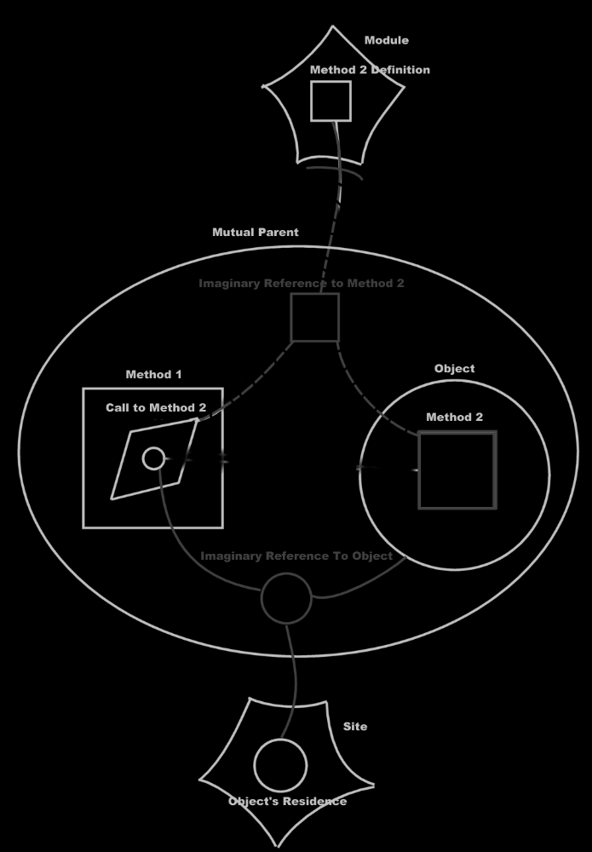

So really, this:

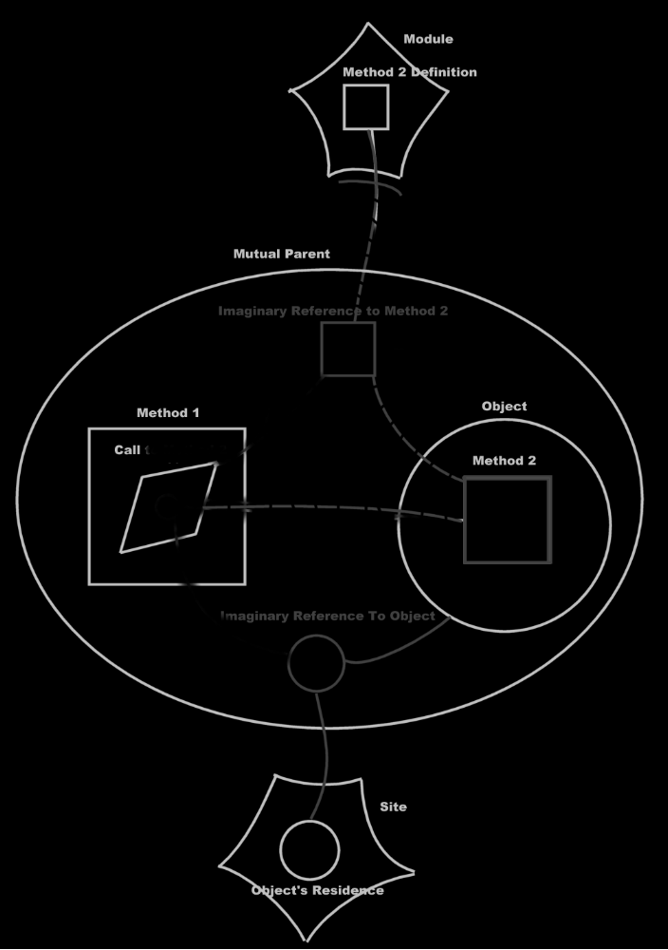

Turns into this:

When you get used to reading the diagrams, you will clearly see that you are calling a command of a module, passing an object on a site to it as a parameter. You also see that nearby there is a reference to the same object, that contains an imaginary reference to the command.

But what you don’t see, is that you are calling a command of an object. That’s what still ‘sucks’ in this notation.

It’s like the call to an object’s command is replaced by a call to a global command, passing the object as a parameter. But you want it the other way around: you want a call to a global command to be displayed as a call to an object’s command. The flat and structured interchange principle commands & classes loosely coupled could also have been called automatic class commands, because global commands should be transformed to class commands automatically.

So it should be the other way around: the last picture should automatically turn into the first picture, and that should be the automatic coupling of the object and the command call.

Expressing a call to a command as a call to multiple objects
The diagrams shown before, is the expression of calling a global command, with its object as a parameter. This turned out to be exactly what I didn’t want to express. Displaying a command as part of a class is much more preferred over displaying the class as a parameter of a command.

When you have to express that one command is called upon two objects, you have to tie the command call to both objects' command definitions.

So it would be a call to both objects' command. Instead of referencing both objects from the command, the command is tied to both command references inside the objects.

In this section I display calling a remote command with two remote objects as parameters. And then I display the same call as calling a remote command on both those objects. It’s basically the same example as above, but now with two parameters.

Call to a global command with two parameters:

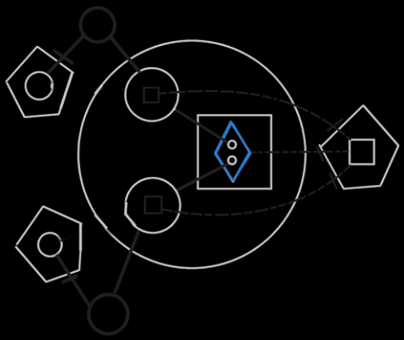

A call upon two objects:

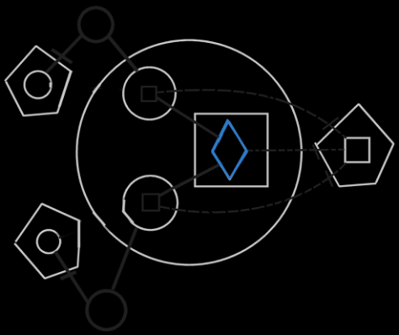

Both pictures express the same physical thing. The first picture displays the objects involved in the command as parameters. The second picture displays the call as a call upon both objects.

This is a better way to express a call to a command, that is part of multiple objects. Looking at the second diagram, you can see that it expresses calling upon multiple objects to execute the same command. It seems a good depiction of calling the same command upon multiple objects. However, there is a flaw.

Command definition accessing the objects
If you are authoring a command, you need to be able to access the object, the command is called upon. When you display the objects as parameters of the command, you can easily use the objects inside the command.

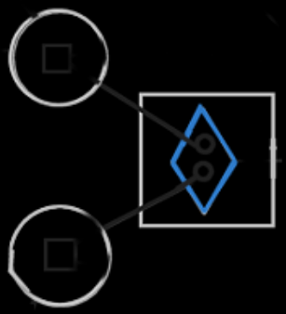

But parameters get replaced by imaginary command definitions inside the classes:

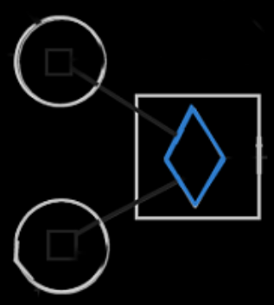

This is because this gives a more intuative view on the process of calling a command upon two object. But then, the references to the objects aren’t accessible inside the command definition anymore.

A solution is to show the objects inside the command anyway.

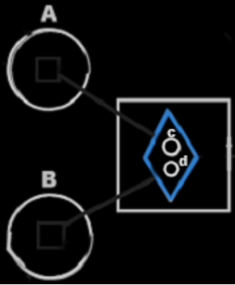

A call upon two objects makes the two object available inside the implementation of the commands. The object symbols of the parameters are sort of like extra imaginary references to the objects.

But the parameters get totally different names, than the objects assigned to them, so you don’t really see which object was assigned to which parameter. This problem is even worse, when both parameters are have the same class. Then you can really not see which object is assigned to which parameter.

The solution is a hybrid display, which connects a parameter to a command inside an object:

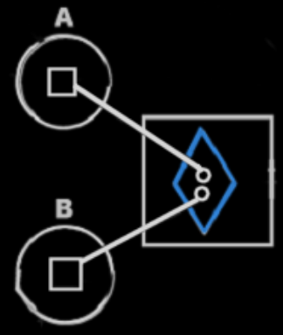

It is an implicit notation, because a connection between two symbols usually means both symbols represent the same thing. A command and an object can’t represent the same thing, so an object and a command can’t really be directly connected to eachother. However, this notation is the clearest way to express it, and really expresses the interchangability between command parameters, and class commands.

Connecting a parameter directly to a command definition inside an object is the implicit notation for interchangability between command parameters and class commands, because it is useful for editing and it is unambiguous as to which objects are called / which object are the parameters.

In object oriented all members of the class, that the command is part of, were available directly from within the command, without qualifying them with the object name, in other words: without accessing them through an object. But in commands and classes loosely coupled, the object a command is called upon is like accessing an object inside the command anyway. But perhaps this notation will be changed in the future. Or perhaps not: this may be a consession you need to make.

Editing a call
First you create a call inside another command.

Then you need to assign a command definition to it, to determine which command you are going to call, unless you will be defining the procedure right then and there, right inside the call. You can assign a command definition in two ways:

- You point the call to an imaginary command reference somewhere or
- you point the call to an imaginary command definition inside an object.

First the way is where you point the call to an imaginary command reference somewhere.

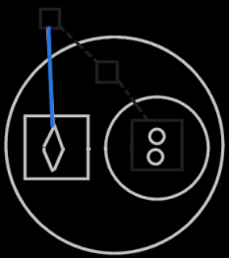

After that, the diagram is transformed, to tie the command to the closest imaginary reference, instead of the arbitrary reference you might have pointed to.

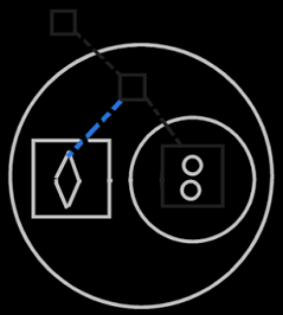

The other way to assign the command definition to a call, is to point the call to an imaginary command definition inside an object.

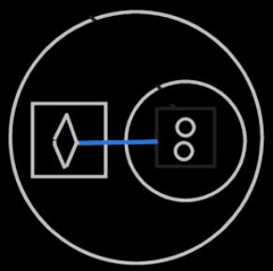

After that, the diagram is transformed to also tie the command call to the closest imaginary reference of the command. Tying the call to a command definition inside an object also assigns one of the parameters of the call, but this is not considered here yet:

Now that you’ve assigned which command to call, the parameters, that are not yet filled in, are displayed inside the command call.

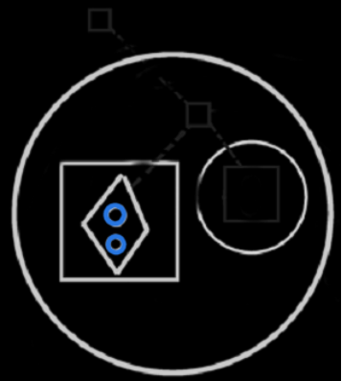

There are three ways to assign a parameter:

- You tie the command call to a command definition inside an object,
- you tie the parameter to an object or
- you tie the parameter to a command definition inside an object

First the way is where you tie the command call to a command definition inside an object.

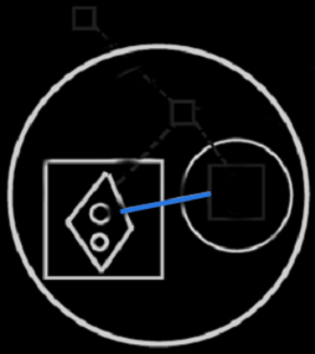

After you picked out the object, the line you drew is replaced by a connection between the parameter, and the command of the nearest imaginary reference to the object.

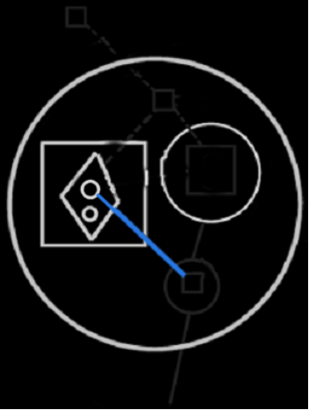

The second way to assign an object to the command, is by tying a parameter to an object reference somewhere.

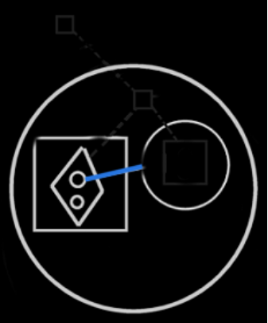

After that, the parameter is replaced by connecting the parameter to the imaginary command definition inside the nearest imaginary object reference.

That’s the end result of the second way to assign a parameter. It is the same end result as the first way to assign a parameter.

The third way to assign an object to the command, is to tie the parameter to a command definition inside an object:

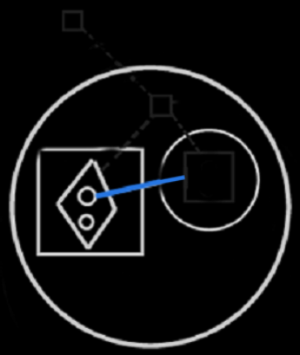

Again, the line is replaced, by connecting the parameter to the imaginary command definition inside the nearest imaginary object reference.

So the following three notations are replaced by the same line:

They are all replaced by the following:

Expression of access to privates
In the diagrams above you can see that a call to a command can be a call upon multiple objects to execute that command. It is not yet discussed, how it is expressed that a command has access to the private contents of a class. Access to the private contents of a class creates a tighter bond between a command and a class. This concept is important. However, the expression of it is not important for now. That will be explained in a different article. The diagrams in this article are merely there for clarafication of the concept and this article is not made to explain diagram expression itself.

Reliability of class interface
When you use a class, you expect the class to have certain commands; you expect it to have a certain interface. But anyone can add a command to the class now, just by using it as a parameter. If a class gets extended with commands, every time you use it as a parameter, the class’s interface changes all the time. This suggests, that a class’s interface is unstable, and not reliable anymore. The data stored inside a class does not changed suddenly like that, but the set of commands accessible through the class can change all the time. What if somebody deletes his command, while everybody was using it, everybody thought it was part of the class, and then all of a sudden it’s not there anymore, and all the dependencies do not function anymore.

However, interfaces in other systems are just as unreliable as in this system, as this section will explain.

If you use a command through a class, you have to be aware of what site the command is part of. You have to be aware, that the class and the command may be authored on a totally different sites. You can see in the diagram on what site a command resides, compared to the class. In diagrams and in text code, things can be given a different color, depending on what site things are coming from. If the command and the class are from the same site or even the same module, the command may be more dependable, than a command from another site or module. You may be using commands, that don’t have a very reliable source. If you want to use commands from other sites, you’re just going to have to know the sites. If you use a command from a vague site, that didn’t even give the command a fixed logical residence, then the command is not reliable. You have to do with the whole internet now, so you have to be aware of where the stuff you are using comes from. This counts for everything: commands, classes, objects, modules. You just need to be aware what site you are accessing.

A command can only be reliable, really, when the people authoring and using the command have a clear agreement about it. That is no different in other systems. Somebody hosting a web service could very well change the interface of the service, and have software, dependent on that service, crash. The only reason that wouldn’t happen, is because people have an agreement with eachother, not to change the interface just like that. And at times it does change unannounced, it really means systems will have problems.

If you access a command through a class, and that command is hosted elsewhere, you have to know you can trust that other site.

If you want more stability and control over the software you are using, you could always host a copy of a dependency (if you are able to copy it). This is analogus to having a software component installed on one of your own machines, instead of accessing a remotely running software component. Even interfaces of components on your local machine are only stable because of the agreement between you and the producer of the component. If they decided to automatically update the component, the interface or behavior of the component may very well change, and this may cause problems for your software. When it doesn’t, than this is because of the agreement, that you have with the other party.

This explains, that a command automatically extending a class, does not make interfaces less reliable than they are today. The next sections explains more about how separation of interfaces is used to make classes more reliable.

Mutual commands, mutual interfaces

A command is an interface
If multiple classes can support the same command, then the classes support the same interface: an interface that has only one command. The interface is represented by the command itself. Each command implicitly creates an interface. That is how it is expressed in a diagram too: a command implicity creates an interface.

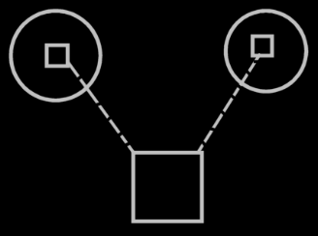

You don’t see triangles around the commands inside the circles, that would specify, that it is a separate interface: each command automatically becomes a separate interface. Just like each object also defines an interface; even though there is no triangle directly inside it, it still has an interface.

Multiple classes can support the same command
As you could see in the previous section: multiple classes, that support the same command, also support the same interface. Multiple classes supporting the same commands logically seems to create overlap in interface, but it doesn’t look like overlap in the diagram.

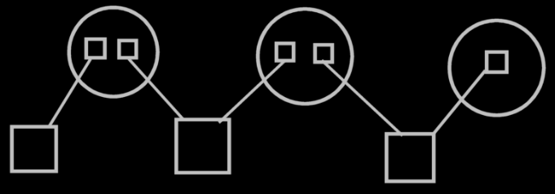

There are just multiple imaginary interface definitions (the circles), that each reference a different set of commands.
So a class referencing multiple commands, referenced by multiple classes, creates a visible interfaces of the class. The visible display of this interface is there, when you display the commands as part of a class, and not when you display the classes as parameters of the commands.

Command extending a class from another system
If two different sites define commands for the same class, this creates two interfaces for the class. If more commands for that class are defined on another site, this creates another interface for that class. This groups the commands of a class by source. That makes it so, that classes can be extended with commands very easily and suddenly, but interfaces don’t change that suddenly. Interfaces are author-bound, so one clumsy author can not mess up an interface authored by the one that authored the class himself. With commands coming from another site, it looks like the class has several command interfaces: one for each site.

It doesn’t need to be a site, that is the logical residence of a command; the logical residence of a command theoretically could also be an object. Each object, that locally defines commands for a class, creates a separate interface for that class.

That way, to extend a class with commands, you don’t need to create a derived class anymore. You can extend a class by simply creating a command that has that class as a parameter. But to extend a class with more data, you do need to create a derived class.

Preventing class’s extension with commands
A class can prevent itself from getting further extended with commands. For instance, you don’t want the class Integer to be extended with any command that uses an integer. It is a question of it being rediculous to maintain a list of all commands that uses integers. Don’t prevent a class from being extended with commands, just because you think it makes your interfaces more reliable. Class Integer can also just make it a default, that it doesn’t get further extended with commands. Some commands that use Integer, you might indeed want to see added to class integer, but you need to actively choose that then. If parameters don’t extend a class with a commands, these parameters are only shown as parameters, and not as commands inside a class definition.
This is basically the same issue as covered in the section Dual & Unary, which explains, when it is rediculous to maintain a backward relationship. For instance: relationships from class Integer back to any class, that uses an integer are rediculous to maintain as well.

Two design dangers
There are two design dangers here: at present day, everybody that knows his way with classes, is used to the fixed logical residence of a command inside a class, and everybody is used to not having his class be extended with commands all of a sudden. There is the danger that people using the new computer language, will give commands a fixed logical residence in a class, and turn on the option not to extend the class with commands. But you’re not supposed to do that! Not fixing a command to a class offers flexibility without unreliability. A class automatically getting extended with commands offers flexibility without unreliability. Perhaps it can be prevented, that people make these design mistakes. Perhaps by only allowing a commands to be defined inside a globality, and by only being able to define it as a default, that a class does not get extended with commands, a default that can always be overridden.

Class data & class commands target definitions
A logical target class only defines data, not commands.
The data and the commands are defined by an imaginary target class. This imaginary target class is defined on a higher level than the logical target class. The class’s imaginary definition resides on a level, that’s above all the sites that define commands for the class.

The logical target class only defines data because commands are too freely definable. Other commands can be way out of sight, on a totally different site, that the class isn’t even aware of. Consider that an object in real life is defined in shape and form, but you can always invent a different use for the object: the object itself doesn’t need to change for that.

The residence of the imaginary class definition depends on the level of detail that you see in the diagram.

The target definitions of commands, as opposed to target definitions of classes, have separate target definitions, separate from the class definitions, and the class commands only indirectly refer to target definitions of commands. The picture below visualizes the concept of class data and class commands target definitions.

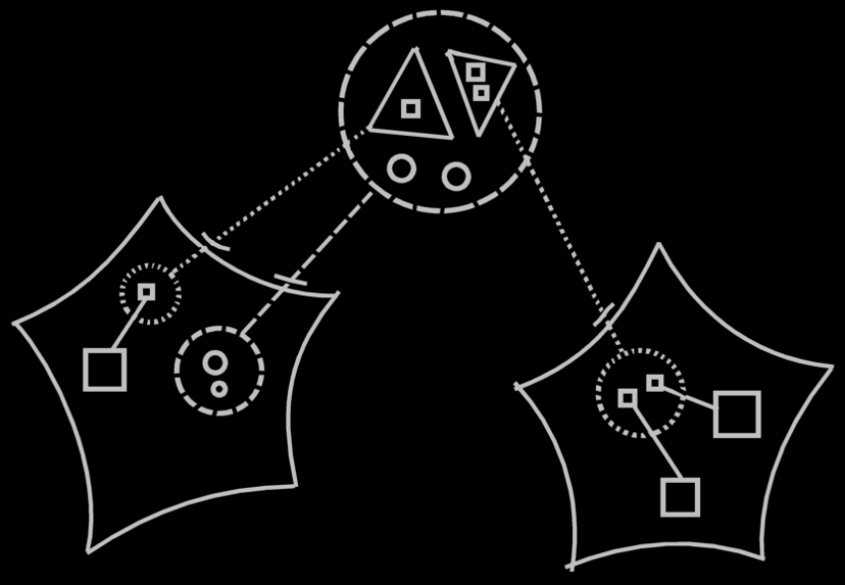

The large dashed circle at the top of the picture represents the imaginary target class, which contains both data (the little circles) and command interfaces (the triangles). The data is part of the actual class, which contains only data. The logical target of this class resides in the site on the left and is represented by a dashed circle, to which the imaginary target class points with a class line. The two command interfaces inside the imaginary class definition at the top of the diagram each point to another site’s command interface. The automatically created command interfaces aren’t real objects. they are imaginary objects. They don’t really exist as objects. Finally, the target command interface definitions on the sites, each contain references to commands defined on that site.

Looking at it like that, you can easily see that a class has several interfaces, but the interface is defined elsewhere, and an interface is definable elsewhere.

The notation above is a clear display of what is going on, but it may not conform to the eventual rules of notation of the diagrams. A discussion about the diagram notation is beyond the scope of this article. The diagram is only intended to clarify the concept.

In the diagram above you can see, that the command interface in the second site, is part of a class on the first site. But what if you zoom in on the second site:

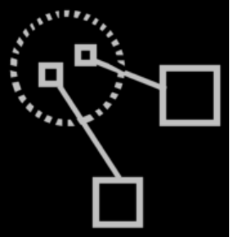

You no longer see the class itself on that level. You need to express somehow, for what class the command interface is defined. The solution is to have an imaginary reference to the class in view. If you define command for a class somewhere, then an imaginary reference to the class needs to be there:

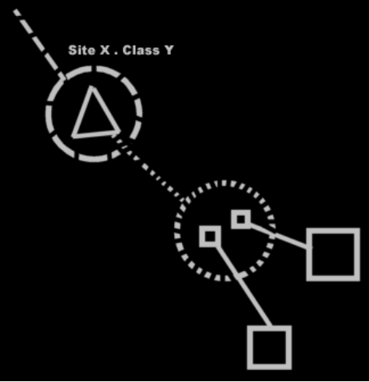

Now an imaginary reference to the class is there in the diagram, the logical target of which is specified by its name (Site X . Class Y), and it is pointing out of the diagram to indicate the target is out of sight.

Objects contain all available commands
Any object of a class contains all data and all available commands. How all the commands can be gathered up is still to be solved: you can’t scan the globe for commands. Actually, any imaginary class definition could also get all data and all available commands, since you also want to see anything available through a class.

Commands in class reuse with inheritance
It used to be an issue if inheritance would still be reliable, when a class’s set of commands can change so easily. The issue was: how does the ‘unreliability’ of a class’s composition affect inheritance? But now we have seen, that the total set of commands of a class may change volatilily, but a specific interface of a class does not change that volatilily. Each site specifies a separate interface of commands for the class, and these interfaces are as reliable as the site itself, and don’t change that suddenly.

The thing is: you shouldn’t really see the commands as part of the class. Only the data is part of the class. Commands are only imaginarily part of the class. In inheritance the data is inherited from the base class. Also, in inheritance every command available from the base class will be available in the derived class. If interfaces or commands from the base class change or get deleted, they also get deleted from the derived class. The interfaces are just as ‘unreliable’ in the derived classes as they are in the base classes. But they’re not that unreliable, as we’ve seen. A class can easily get more interfaces, but an existing interfaces are as reliable as the site the interface is defined on.

Commands in reuse of interfaces
It also used to be an issue, whether the reuse of interfaces would still be reliable, when a class’s set of commands can change so easily. Every object symbol was able to serve as an interface, so when an object’s set of commands can change so suddenly, what good is it to use the object as an interface definition, that defines the expected interface.

The full command interface of a class may be unreliable, but a specific command interface of a class is not. You will be more likely to reuse a specific command interface of a class, rather than to borrow the whole command interface of a class as an interface.

Inactive command references
In the explanations above only command calls were considered, not inactive command references. Inactive command references don’t work the same as calls.

Calls have parameters filled in. Inactive command references don't have parameters filled in. So they also don’t call upon objects. Only as a command reference gets called again, objects assigned to the call’s parameters.

The object of the parameter is not determined yet in an inactive command reference. However, the class of the parameter may be determined after all. Therefore, the parameters in an inactive command references may be tied to a command inside class with a class line.

Local variables
Local variables, as they are called in contemporary programming languages, are a lot like parameters. Unlike parameters, they are private to the command, rather than publically written or read. Local variables are private contents of a command. Since they can not be publically set, and you can not determine what object the private variable will hold, the command also can not become part of any arbitrary object of the class of the local variable.
So the command does not become part of each object of the class of that local variable, because the object of that local variable can not be freely appointed.

The local variable might make the command part of the class anyway, but then as a static command, that can be called on the class, but not on any arbitrary object.

Extensive classification with interfaces
A command implicitly creates an interface: an interface that has only one command. When commands for a class are implemented on a site, this also creates an interface for the class. These interfaces are defined automatically. Commands & classes loosely coupled creates interfaces, that already have an implementation. You are not borrowing an interface from elsewhere, and then giving it a new implementation.

commands & classes loosely coupled leads to the idea of automatic definition of interfaces. Manually defined interfaces also still exist. Rules for extensive classification through interfaces will be discussed in the article Extensive classification through interfaces. Extensive classification through interfaces is about automatic definition of interfaces, as well as manual definition of interfaces. There may be more automatic definitions of interfaces, than just the one concerned with commands & classes loosely coupled, but this will be discussed in Extensive classification through interfaces.

Conclusion
Perhaps there will be other ways interfaces will be automatically defined, but that’s not important for now. For now it is important to understand,
that command parameters are interchangable with class commands,
that multiple classes can support the same command,
and that mutuality of commands creates mutuality of interfaces,
and that different sources of commands are seen as different interfaces for a class, which makes interface of a class reliable, even though the full set of commands of the class is very variable.

Author & Copyright: Jan-Joost van Zon Date: April 27, 2008 – May 18, 2008 Location: Oosterhout, The Netherlands Status: Finished

Ideas
Commands & Classes Loosely Coupled,

Making a command part of multipe objects,

But in their bare form commands are independent entities. If a command has a parameter, that does not have a class, the command becomes available from any object that has access to the command, yes. If a parameter does have a class, then the command becomes available from any object of that class.
But in essence, a command is a separate entity. Making it also part of objects and classes, is secondary to that. How to establish, that each object has an imaginary reference to the command is not entirely clear yet. To update every object that can access the command or every object of a certain class, that can access the command, might be undoable, so indexing that might be horrible to do. But the scanning which commands are available to the object whenever you show the object on screen, is horrible too. Perhaps you do have to actively aquaint sites with objects with other sites, so that they either index eachother, or scan eachother, at least: scan a limited amount of the internet, not the whole internet, that is undoable.

JJ

Commands & Classes loosely coupled,
2008-08

Keep in mind, that in earlier articles it was explained, that a command is a separate entity, as opposed to being part of a specific class.

JJ

Classes & commands loosely coupled as relations between commands and objects
Parameters are the essential connection between commands and objects. If I can use a line merge in bidirectional relations between classes, does that mean that a line merge between a command parameter’s class line and a class command’s definition line should be considered a bidirectional relation between a class and a command? Should that be viewed more like a relationship, than anything else?

When a command definition gets an object with a class, this creates a relation between the command and the class definition. This means, that the class definition also gets a reference back to the command.

It looks like, when you turn a command into an executable object, without any additional effort automatically establishes the interchangability between class commands and command parameters. I didn’t expect that. If two seemingly independent concepts confirm eachother, I must be on the right track.

For objects of the class, this means, that they copy all methods of the class.
If the method changes, this changes the class configuration. The change in class configuration must then be ventilated through to all the objects of the class.
I haven’t accounted for that yet. The same effect is there for just data of objects: if the class configuration changes, the objects should change also.
Gee… you should be versioning. Objects do not change, because they link to a specific version of the class.
However when creating a command, and giving it a relation to a class, I guess I do want the command to be ventilated through to the objects? Or will I just forget about that?
Gee, the commands inside an object are no longer imaginary references. They are real ones now.
I guess, that only if you link to the development version, changes are ventilated through from the classes to the objects.

But command as a concept, as a way to establish interchangability between class commands and command parameters, also needs to subdivise the class commands into interfaces: one for each module commands are defined in.
How that is established by command as a concept is yet to be determined.

Automatic Containment for Relations is still a problem. Line merges for relations between commands and objects may have the same problem. I didn’t account for that earlier. A good example of this problem is yet to be drawn out.

Giving the issues in this section a place
Classes & commands loosely coupled needs to be adapted.

You can postpone explaining commands till later, explaining it first and foremost in terms of relations between commands and normal objects.

An object's references to its commands are not imaginary.

Still ignore, that also for relations between objects and commands the diagram notation has discrepancies with the diagram notation of automatic containment.

Other Ideas
- Update Commands & Classes loosely coupled

Mention in it the connection between command parameters and class commands, next to the connection between call arguments and object commands.

